1: POSTIVE/NEGATIVE/ZERO

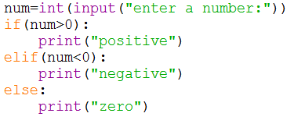

OUTPUT:

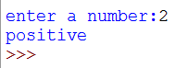

2:READ A CHARACTER FROM BY USER. CHANGE INTO UPPER/LOWER

PROGRAM:

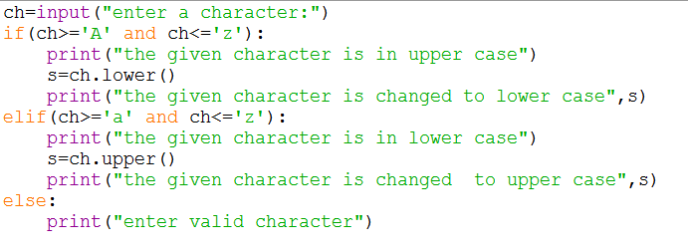

OUTPUT:

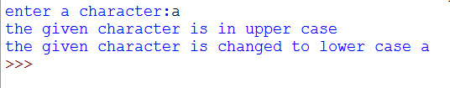

3: SALARY BONUS

PROGRAM:

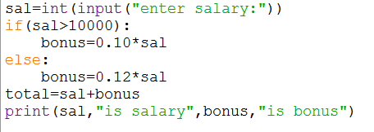

OUTPUT:

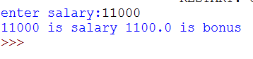

GROUP 3

1: LEAP YEAR OR NOT

PROGRAM:

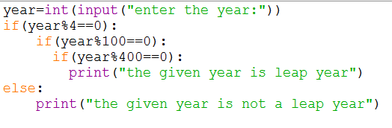

OUTPUT:

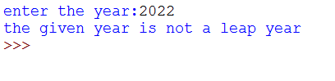

2: READ A CHARACTER.ITS UPPER UNIT U

PROGRAM:

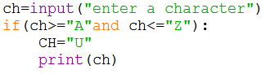

OUTPUT:

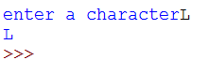

3: GENDER BONUS

PROGRAM:

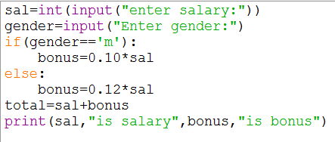

OUTPUT:

